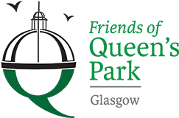

Friends of Queens Park - Agenda

Meeting Tuesday 15th March, 2022 at 7pm – Wellcroft Bowling Club, Glasgow

Meeting Agenda

- Welcome to Visitors – Registration SD
- Approval of Previous Minutes SD
- Matters Arising – Park Working Group SD
- Treasurer’s Report GMc
- Volunteering JM/SR
- Funding applications – Area Partnership, Ross & Liddell, Awards for All JM

- Priority Park Areas – Rose Garden, Raised bed, Queen Vic, Wild-life Rockery SR

- Succession Planning – Chairperson SD

- Queen’s Park Arena – update SD

- Park Lighting SR
- AOB ALL
- Date of next meeting to be decided - Wellcroft Bowling Club

* To ease printing costs could you please bring your own copies of Minutes and Agendas

