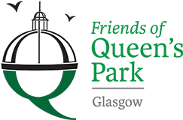

Friends of Queens Park - Agenda

Meeting Tuesday 15th November, 2022 at 7pm – Wellcroft Bowling Club, Glasgow

Meeting Agenda

- Welcome to Visitors/New Members – Registration SR
- Approval of Previous Minutes SR
- Matters Arising – Park Working Group, Rose Garden, Park Lighting Workshop,
Website
- Treasurer’s Report GMc
- Friends of Langside Library – update from meeting SR/JM
- Social Media Strategy – Marnie Silver
- Children’s Playground Sub Group – update SK
- Funding Applications – update JM
- AGM/Constitution JM/SR

- Volunteering Sessions – change of meeting times JM
- AOB – Park Display Cabinet, Moira Jones, Wildlife Garden
- Date of next meeting 17/01/2023 - Wellcroft Bowling Club

* To ease printing costs could you please bring your own copies of Minutes and Agendas

