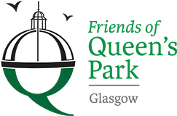

Friends of Queens Park - Agenda

Meeting Tuesday 17th May, 2022 at 7pm – Wellcroft Bowling Club, Glasgow

Meeting Agenda

- Welcome to Visitors/New Members – Registration SR
- Approval of Previous Minutes SR
- Matters Arising – Park Working Group SR
- Treasurer’s Report GMc
- Volunteering JM/SR

- ‘Volunteering Policy’ JM

- Summer/Autumn Work Plan – Rose Garden etc. SR
- Funding applications – Children’s Play Ground/Green Gym JM

- FoQP Website

- Succession Planning – Chairperson/Committee ALL

- Park Maintenance ALL

- Queen’s Park Arena – update
- AOB ALL
- Date of next meeting to be decided - Wellcroft Bowling Club

* To ease printing costs could you please bring your own copies of Minutes and Agendas

