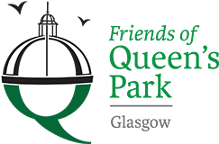

Friends of Queens Park - Agenda

Meeting Tuesday 19th July, 2022 at 7pm – Wellcroft Bowling Club, Glasgow

Meeting Agenda

- Welcome to Visitors/New Members – Registration SR
- Approval of Previous Minutes SR
- Matters Arising – Chair Resignation, Park Working Group, Community Payback
Volunteering, Volunteering Policy, Website, Youth Philanthropy Group SR
- Treasurer’s Report GMc
- Children’s Playground – proposed sub group JM
- Summer/Autumn Work Plan – Rose Garden etc. SR
- Funding applications – Children’s Play Ground/Green Gym JM

- Succession Planning – Chairperson/Committee ALL

- Park Maintenance ALL
- AOB ALL
- Date of next meeting 20/09/2022 - Wellcroft Bowling Club

* To ease printing costs could you please bring your own copies of Minutes and Agendas

