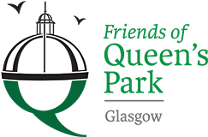

Friends of Queens Park - Agenda

Meeting Tuesday 20th September, 2022 at 7pm – Wellcroft Bowling Club, Glasgow

Meeting Agenda

- Welcome to Visitors/New Members – Registration SR
- Approval of Previous Minutes SR
- Matters Arising – Park Working Group, Community Payback Team, Instagram SR
Account
- Treasurer’s Report GMc
- Children’s Playground Sub Group – update SK
- Rose Garden SR
- Funding applications – update JM

- Succession Planning – Chairperson/Committee ALL

- Park Maintenance ALL

- Park Lighting – consultation JM
- AOB ALL
- Date of next meeting 15/09/2022 - Wellcroft Bowling Club

* To ease printing costs could you please bring your own copies of Minutes and Agendas

