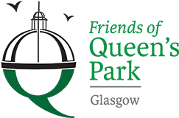

Friends of Queens Park - Agenda

Meeting Tuesday 21st March, 2023 at 7pm – Wellcroft Bowling Club, Glasgow

Meeting Agenda

- Welcome to Visitors/New Members – Registration SR
- Approval of Previous Minutes SR
- Matters Arising – SR
Park Working Group
Scottish Poetry/Rose Garden
Children’s Playground
Display Cabinets/New Posters
Social Media Strategy
Letter of Complaint
TCV Info. Sheet and Survey
Glasgow Tree Lover’s Society Membership
- Treasurer’s Report GMc

- Recuitment of Treasurer, Secretary and Volunteer Leader JM

- Volunteering Sessions – priorities for Spring/Summer/Autumn
- Wildlife – Night Walk MG

- Funding Application/s – update JM

- AOCB

- Date of next meeting 16/05/23 - Wellcroft Bowling Club

* To ease printing costs could you please bring your own copies of Minutes and Agendas

