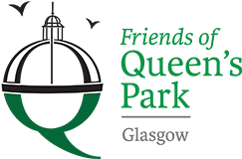

Friends of Queens Park - Agenda

Meeting Tuesday 16th May, 2023 at 7pm – Wellcroft Bowling Club, Glasgow

Meeting Agenda
- Welcome to Visitors/New Members – Registration SR
- Approval of Previous Minutes SR
- Matters Arising – SR/JM/
Park Working Group MG/AB
Scottish Poetry/Rose Garden MS
Children’s Playground
Social Media Strategy
Wildlife – Night Walk
Moira Jones Memorial
Leeds University Research Project
- Treasurer’s Report GMc

- Recuitment of Treasurer, Secretary and Volunteer Leader JM/TO

- Governance JM

- Volunteering Sessions – Summer/Autumn SR
- Funding Application/s – update JM

- AOCB

- Date of next meeting 18/07/2023 - Wellcroft Bowling Club

* To ease printing costs could you please bring your own copies of Minutes and Agendas

