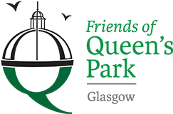

Friends of Queens Park - Agenda

Meeting Tuesday 18th July, 2023 at 7pm – Wellcroft Bowling Club, Glasgow

Meeting Agenda
- Welcome to Visitors/New Members – Registration SR
- Approval of Previous Minutes SR
- Matters Arising – SR/JM/
Park Working Group MG/AB
Scottish Poetry/Rose Garden - Event MSTO
Children’s Playground SK
Social Media Strategy TO
Digital Report MS
Wildlife Walk MG/AB
AGM – 21st November JM
- Treasurer’s Report GMc

- Recuitment of Treasurer & Secretary JM/GMc

- Volunteering with FoQP MS

- Wildlife Pond – water supply & clearance of debris ALL

- Funding Application/s – update JM

- AOCB ALL

- Date of next meeting 19/09/2023 - Wellcroft Bowling Club

* To ease printing costs could you please bring your own copies of Minutes and Agendas

